Project Design Phase-II
Data Flow Diagram & User Stories

Date | 07 February 2026
Team ID | LTVIP2026TMIDS87294
Project Name | ResolveNow: Your platform for online complaints
Maximum Marks | 4 Marks
Data Flow Diagrams:
A Data Flow Diagram (DFD) is a traditional visual representation of the information flows within a system. A neat and clear DFD can depict the right amount of the system requirement graphically. It shows how data enters and leaves the system, what changes the information, and where data is stored.

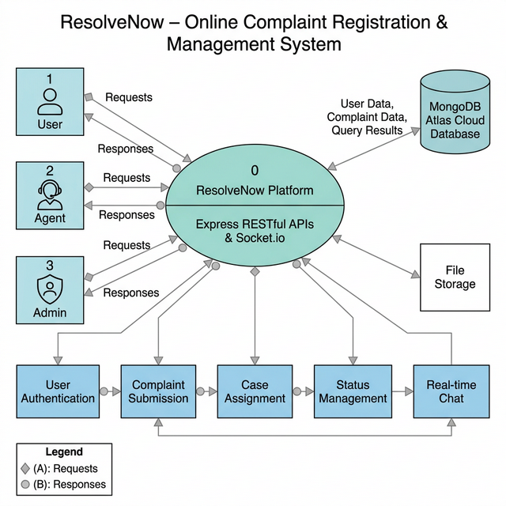
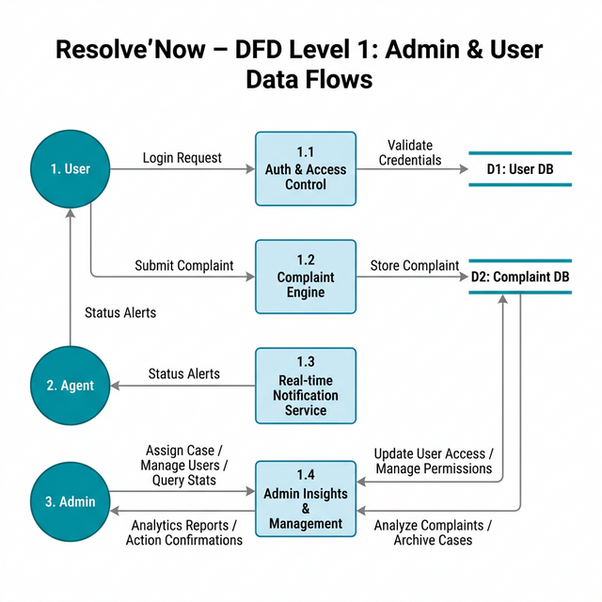

User Stories

User Type | Functional Requirement (Epic) | User Story Number | User Story / Task | Acceptance criteria | Priority | Release
Customer (Web User) | Registration | USN-1 | As a user, I can register using email and password | Account created & dashboard accessible | High | Sprint-1
Customer (Web User) | Authentication | USN-2 | As a user, I can log in securely | Successful login redirects to dashboard | High | Sprint-1
Customer (Web User) | Complaint Listing | USN-3 | As a user, I can view available complaint categories | Category list loads from database | High | Sprint-1
Customer (Web User) | Complaint Submission | USN-4 | As a customer, I can submit a complaint with issue type & priority | Complaint status shows "Pending" | High | Sprint-2
Customer (Web User) | Document Upload | USN-5 | As a user, I can upload evidence documents during submission | File uploads successfully | Medium | Sprint-2
Support Agent | Complaint Management | USN-6 | As an agent, I can accept or reject assigned complaints | Status updates to Resolved / Rejected | High | Sprint-3
Administrator | Agent Approval | USN-7 | As an admin, I can approve agent registrations | Approved agent visible in system | High | Sprint-3
Customer (Web User) | Notifications | USN-8 | As a user, I receive complaint status updates | Notification displayed in dashboard | Medium | Sprint-4
Customer (Web User) | Complaint History | USN-9 | As a user, I can view my complaint history | Previous complaints visible in dashboard | Medium | Sprint-5

